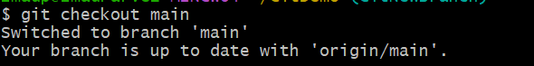

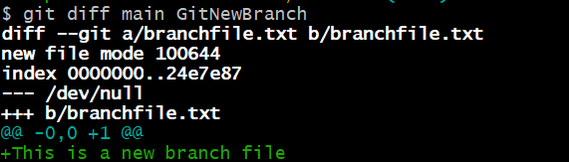





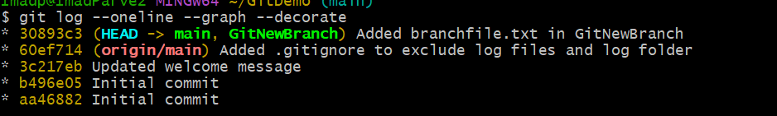

Screenshot 2025-08-10 232250

